The Brexit Tuition Shock and the Price Elasticity of International Students: Evidence from a Natural Experiment
Stoycho Rusinov*
James Rafiki Aketch**

*Center for the Study of Democracy, Sofia
University of Mannheim, Germany
email: stoycho.rusinov@csd.eu

**School of Economics, University College Dublin

ABSTRACT
This paper estimates the price elasticity of EU demand for UK higher education using the post-2021 Brexit-induced loss of Home Fee status and student-loan access as an externally imposed tuition shock. Unlike standard studies based on enrollment, we use UCAS applicant counts to observe expressed demand before universities ration admissions. A weighted difference-in-differences design with country and year fixed effects produces country-specific post-reform effects that are closely reproduced by synthetic difference-in-differences estimates. The reform reduced EU applicant numbers by approximately 67% on average, with substantial and persistent variation across origins. When the reform is treated as a common nominal price change, the implied elasticities exceed conventional estimates and surpass 1.5 in absolute magnitude for several countries with applicants from lower-income origins appearing more responsive. However, the pre-Brexit fee was financed through an income-contingent loan whose present value varies with origin-specific earnings, repayment thresholds, and the subjective discounting of future payments. We therefore map the same estimated treatment effects across country-specific effective price changes and a range of subjective discount rates. The relationship between elasticity and GDP per capita becomes statistically insignificant at approximately 6% subjective discount rate and reaches income neutrality at approximately 14.9% subjective discount rate. Many implied elasticities then approach the ranges reported in the literature, although some still remain above one in absolute magnitude. The results show that cross-border demand elasticity depends on baseline financing conditions and that the UK student-loan system operated as an equalizing institution for European educational mobility.

JEL codes: I22; I23; F22; J61; D12; C23
Keywords: Brexit; international student mobility; higher education demand; tuition fees; price elasticity; EU students; UCAS applicants; difference-in-differences; synthetic control; income-contingent loans; educational mobility; heterogeneous treatment effects.

1. Introduction
International higher-education demand studies struggle to isolate own-price elasticity because they generally infer demand from enrollment changes, lack sufficient exogenous price variation, or face both problems simultaneously. Many estimates of the price elasticity of college enrollment “treated the application decision as exogenous, focusing only on how price affects the college-going behavior of admitted applicants” (Savoca, 1990), and so “ignored the possibility that a tuition change affects enrollment through the applicant pool” itself (p. 123). Standard demand models using enrollment data therefore conflate the desire to attend with the university’s choice to admit. Recent extensions retain this enrollment-based approach. McQuone and Simons (2025), updating Conlon et al. (2021), estimate short-run elasticities between −0.54 and −0.81 for non-EU students, magnitudes that remain too small to account for the post-2021 collapse observed in several EU-origin applicant series.
To address the lack of exogenous tuition variation and the limitations of enrollment as a demand proxy, we treat the number of Universities and Colleges Admissions Service (UCAS) applicants from each domicile as expressed origin-country demand before universities ration places. Applicant counts are observed before admission decisions, offers, acceptances, and enrollment. Identification comes from within-country changes over time around the externally imposed loss of Home Fee status and loan access. Because the financial consequences varied across origin countries, the design also permits country-specific treatment effects that can be mapped to constant-elasticity demand responses under the maintained price-shock assumptions.
The larger applicant declines from lower-income EU origins do not by themselves establish inherently more elastic preferences. Although Brexit imposed a common nominal price shock, its effective treatment intensity differed across origins because the value of the lost income-contingent loan depended on country-specific earnings, repayment thresholds, and the subjective discounting of future repayments. We therefore rescale the estimated country effects across a range of subjective discount rates. The relationship between elasticity and GDP per capita becomes statistically insignificant at a discount rate of approximately 6% and reaches income neutrality at approximately 14.9%, while many of the implied elasticities move towards the ranges reported in the literature. The cross-country ordering of price responsiveness is therefore shaped by the financing conditions embedded in the pre-Brexit system. We therefore show that demand elasticity cannot be interpreted independently of the effective price experienced by applicants.

2. Context

2.1. Brexit and higher education
Between 1940 and the early 1990s, the US market for baccalaureate education grew far more competitive, moving from largely local markets to a nationally integrated system. Hoxby (1997) argues that this intensified competition over students and institutional quality can explain real tuition increases of about 50 percent among selective private colleges. A related shift toward market competition later occurred in England, where reforms from 2012 expanded tuition-fee competition, encouraged private providers, and increased information for prospective students. Brown (2011) questioned whether these reforms would improve quality and financial sustainability, warning the evidence was limited, and the system could become more stratified and wasteful. These reforms developed alongside a longer-standing commitment to widening participation, which sought to make higher education accessible to groups that had not traditionally considered it.
Against the broader expansion of globalized higher education, Brexit was a major reversal of UK-EU integration. Calhoun (2017) reads the Leave vote partly as a populist reaction against London-centered globalization and cosmopolitan elites seen to have benefited disproportionately, accompanied by nostalgia for an earlier Britain and frustration with existing conditions. For higher education, the most consequential outcome was the rupture of academic and financial ties with the EU. The 2020/21 academic year was the last in which new EU students generally qualified for Home Fee status and government-supported loans. From 2021/22 they became liable for international fees, which often doubled or tripled their costs. Brexit therefore produced one of the largest discrete tuition shocks faced by a clearly defined group of students in twenty-first-century British higher education.
Brexit raised financial and reputational concerns about recruiting EU students and staff, accessing European research funding, and UK students studying abroad (Mayhew, 2022). Even so, the UK remained the world’s second most popular destination for international students in 2023. About 730,000 international students were enrolled at UK universities in 2023/24, some 25 percent of the student population, and their fees generated 23 percent of total university income (Cuibus et al., 2025). Cuibus et al. (2025) report that EU numbers fell sharply after Brexit and then stabilized, so that by 2023/24 EU students were only 7 percent of newly enrolled international students. Mayhew (2022) notes that the decline in EU enrollments during 2021/22 was offset by growth among UK and non-EU students, which illustrates that enrollment is an equilibrium outcome jointly determined by applications, offers, acceptances, and institutional capacity.
This shift also reshaped student mobility. As early as 2006, Findlay et al. (2006) note that UK students’ decreasing mobility to Europe was more than compensated by rising flows to other destinations, especially North America and Australia (p. 291). Locke and Marini (2021) note a rapid pre-2016 increase in EU faculty in UK institutions, many of which had come to rely on academics from other EU countries for much of their research and teaching. Luthra (2020) argues that rejecting free movement left EU staff feeling insecure about their legal rights and public acceptance at work.

2.2. Previous attempts to capture demand elasticities in higher education
Causal evaluation of the 2021 reform became possible only once enough post-treatment UCAS observations accumulated. Before that, policy reports relied on forecasting. Conlon et al. (2021), for instance, estimated error-correction models and used the resulting elasticities to simulate the response to the new regime. Once data through 2022 arrived, the literature moved from ex ante forecasting to ex post evaluation. Neville et al. (2024) document a sharp decline in successful EU applications after 2021, even net of COVID-19. Clifton-Sprigg et al. (2025) separate the components of Brexit and conclude that international tuition fees, not the referendum result or visa requirements, drove the contraction in EU student mobility. Crawford et al. (2025) provide complementary evidence to Conlon et al. (2021) on demand elasticities.
Savoca (1990) argues that enrollment-based estimates understate demand sensitivity by conflating application, admissions, and matriculation decisions. If tuition and admissions policy are set independently, the enrollment elasticity equals the sum of the application and matriculation elasticities, which she estimates at −0.49, so true demand elasticity may be more than twice the conventional estimates. Consistent with this, Dwenger et al. (2012) find that among German high-school graduates, living in a state with tuition fees lowers the probability of applying to a home-state university by 2 percentage points (against a 69% baseline), with stronger responses among higher-achieving students.
Savoca’s (1990) criticism applies more broadly, however, to models that treat observed enrollment as demand without explicitly modeling the preceding application and admission stages. It is especially relevant to BLP-type models, building on McFadden (1974), when elasticities are derived from enrollment shares across differentiated alternatives. Although such models are micro-founded and can accommodate preference heterogeneity, fully representing the student demand curve becomes increasingly demanding once applicants face different choice sets, prices, admission probabilities, and financial conditions. This becomes even more difficult when students from different countries face distinct circumstances at the time of application. Therefore, applicant counts aggregated at the country level may capture the market-level application response more directly, albeit at the cost of averaging over individual preference heterogeneity.
When elasticity is estimated with over-time variation rather than cross-sectional variation, estimates using enrollment instead of the number of applicants are also problematic, especially since tuition is now also endogenous. This creates a simultaneity problem between tuition and enrollment. To that end, Leslie and Brinkman (1987) write the conventional elasticity as ε = E/P, with E the percentage change in enrollment and P the percentage change in price. To read this ratio causally, one requires tuition to be exogenous to demand and to other determinants of enrollment. This condition is rarely satisfied because institutional variation is driven by competitive pricing and quality changes, not exogenous shocks. To illuminate this point, Hoxby (1997) shows that greater integration and competitiveness in the US market raised average tuition and quality, increased differentiation, strengthened sorting by student quality, and changed subsidies. Posted tuition may therefore respond to the same forces that drive enrollment, and when tuition rises alongside quality and differentiation, the product is no longer held constant. Campbell and Siegel (1967) give an example where tuition rose 148% between 1927 and 1963, more than total direct costs, implicating that their tuition elasticity of −0.44 understates the true total-cost elasticity.
Methodologically, Conlon et al. (2021), seeking a specific EU elasticity, acknowledge that tuition fees are “among the variables that are the same across countries”, then estimate elasticities from a country panel with no within-year cross-country price variation, so they identify the tuition coefficient only through the common time series. Conlon et al. (2021) nonetheless claim the cointegrating coefficient measures the causal effect over future periods (p. 19) and find a statistically significant long-run elasticity implying that a 10% fee increase for EU full-time first-year undergraduates lowers demand by 3.5% (an elasticity of 0.35, which we return to later). Clifton-Sprigg et al. (2025) divided the ATT implied post-2021 change in applications by a 140% price change to obtain about 0.40. In the Appendix, we show why this understates the true slope of an isoelastic demand curve when the price shock is large.
Our closest predecessor is Sá (2014, 2017, 2019) who used UCAS application data and a related difference-in-differences design to estimate the response to the 2012 tuition reform. The 2014 working paper reports magnitudes between 0.14 and 0.26, while later versions report both a reform-specific 0.110 and a full-period 0.356 (Sá, 2017; Sá, 2019) elasticities. The gap between the latter two decomposes into four parts. First, the 0.110 reflects the 18.7% application decline relative to the 170% arithmetic fee increase; on the log-log scale of Table 10, it becomes 0.207 over ln(27,000/10,000), or 0.208, accounting for 40.0% of the 0.246 gap. Second, valuing the reform by the sector-average increase from £10,395 to £24,120 (Sá, 2014, Section 6.1) rather than the maximum-fee increase from about £10,000 to £27,000 (Sá, 2017, Section 4) raises the implied elasticity to 0.246, a further 15.3%. Third, the 2014 coefficient of −0.250, using 2012 and 2013 as post-treatment, gives 0.297 and explains another 20.8%, consistent with the later recovery as the annual coefficient narrows from −0.237 in 2013 to −0.182 in 2014 and −0.172 in 2015. The remaining 24.0% reflects sample coverage and specification.
Overall, the literature has remained broadly consistent in finding that price elasticities in higher education typically range in absolute magnitude from approximately 0.10 to 0.70-0.80 (Savoca, 1990; Sá, 2014; Crawford et al., 2025; Conlon et al., 2021; Dwenger et al., 2012; Crawford et al., 2025)), depending on the choice of denominator, fee assumptions, type of price variation, and baseline assumptions. Althrough, most of those papers failed to account for the implicit effects of the income-contingent loans that were supporting such numbers, we will reconcile our estimates regardless. We retain this range as a later benchmark for the subjective present-value calibrations that follow in the methodology section.

2.3. Watch the denominator
The major problem in the literature, as we understand it so far, is that nominal tuition changes are confused with the change students actually experience when elasticity is computed. Sá (2019) for the tuition reforms from 2012 and Clifton-Sprigg et al. (2025) for the actual Brexit shock, and most of the literature compute price shifts as if students are jumping from one tuition to another without discounting the fees. This understates the denominator in the elasticity equation (change in demand/change in prices) because students exposed to the pre-Brexit loan regime can subjectively discount the loan's present value and experience the old price as much lower than 9250 pounds. In contrast, the new EU tuition regime in the UK – absent from such financial mechanisms – is treated as immediate payment with zero subjective discounting, producing a substantially larger experienced price shift.
To demonstrate similar mechanisms, a large experimental literature documents substantial subjective discounting of delayed outcomes, although estimated rates vary considerably across settings and elicitation methods. Drawing on 927 estimates from 56 studies, Matousek et al. (2022) report a publication-bias-corrected mean annual discount rate of 33%. Their results also indicate that discounting differs across domains, with individuals displaying greater impatience over health outcomes than over money, while negative framing is associated with greater patience.
More directly relevant to the valuation of deferred loan repayments, Li et al. (2022) elicit time preferences from 2,100 UK adults by asking participants to choose when to repay hypothetical credit balances of £500 or £5,000 under different borrowing costs. They estimate mean annual discount rates of 6-7% across the full sample. However, these averages are pulled downward by more than half of participants who selected immediate repayment and were assigned a discount rate of zero. Among participants who preferred to delay repayment, estimated annual discount rates range from approximately 9% to 15%, while those selecting the maximum delay at an interest rate of 35% reveal discount rates of at least 35%. Li et al. (2022) also conclude that “persons aged 60 and financially literate tended to minimally delay repayment and have a consistent choice trajectory, while participants aged 18–30 who are financially less literate tended to make more contradictory choices and have a higher discount rate.” (p. 65), although this changes with higher loan sizes. Their estimated mean conditional discount rates range between 0.11 and 0.24 across both of their treatment groups.
Evidence from consequential financial decisions points in a similar direction. Warner and Pleeter (2001) examine more than 65,000 military personnel who had to choose between an immediate lump-sum payment and a future annuity. The break-even discount rates exceeded 17%; most participants selected the lump sum, demonstrating a strong preference for immediate payment and reducing government separation costs by approximately $1.7 billion.
The estimates reported by Li et al. (2022) and the broader literature in subjective discounting provide a direct empirical benchmark for the subjective discount-rate parameter introduced in our methodology. To account for the distinction between nominal and experienced prices, the current design estimates elasticities across a range of possible subjective discount rates. We then identify how strongly students would need to have discounted future income-contingent repayments for the observed post-Brexit collapse in applicant numbers to be consistent with the elasticity range reported in the previous literature (reported in the end of section 2.2)

3. Data
The primary source is the most recent UCAS (2025) data release, covering application cycles from 2016 to 2025. UCAS centralizes applications to UK institutions, letting us observe applicant behavior before admissions decisions, which is central to the design because applicant counts capture expressed demand before rationing. The data report applicant counts by country of domicile with demographic breakdowns. We aggregate across all categories of sex and gender to obtain total demand from each origin country, keeping domicile as the key dimension of variation. Deriving gender-, age-, or subject-specific elasticities places concerns regarding small cells and OLS aggregation methods, to avoid those we use only country level statistics and propose the other desegregations as future work.
UCAS (2025) also reports the typical changes in definitions as in previous editions. UCAS (2024) includes the time series from 2006 to 2024, while UCAS (2025) only includes the series from 2016 onwards. Because definitions and methodologies may differ between database versions, we don’t merge the two UCAS editions. We also want to mention that UCAS is, at its core, an administrative database. Administrative databases, although census-level, have their own internal limitations (cite, cite). However, microdata covering thousands of vastly heterogeneous student populations applying to UK higher education institutions for the period between 2020 and 2021 does not exist and could not be obtained ex-ante. Using the Higher Education Statistics Agency (HESA) only provides enrollment numbers. Although it is vastly superior to most data out there, it still suffers from the same pathologies of being an administrative database.
The unit of observation is the origin-country-year, a panel of both EU countries (treated) and non-EU countries used to build the pseudo EU (control). The outcome is the log number of applicants from country i in year t. To study heterogeneity in the response, the UCAS data are merged with World Bank macroeconomic indicators, including GDP per capita and labor-market variables. Table 1 reports descriptive statistics.
Table 1. Descriptive statistics of the core variable in the analysis for both the treated and control groups. Statistics are computed on the 468 country-year World Bank estimation sample (52 countries over 2016 to 2024). Education spending as a share of GDP is available for 321 of these observations and does not restrict the sample.
Variable | n | mean | sd | median | min | max
Donors matching sample (applicants > 100)*
Applicants | 546 | 1519 | 2359 | 645 | 100 | 26655
Baseline DiD sample**
Applicants | 520 | 1765.11 | 3903.00 | 667.5 | 30.0 | 36385.00
Synthetic DiD sample**
Applicants | 1200 | 1095.35 | 2864.01 | 330.0 | 25.00 | 36385.0
World Bank (WDI) regression sample**
Applicants | 468 | 1767.95 | 3745.32 | 715.00 | 35.00 | 33660.00
log_app | 468 | 6.63 | 1.23 | 6.57 | 3.56 | 10.42
EU | 468 | 0.50 | 0.50 | 0.50 | 0.00 | 1.00
Post | 468 | 0.44 | 0.50 | 0.00 | 0.00 | 1.00
did | 468 | 0.22 | 0.42 | 0.00 | 0.00 | 1.00
event_time | 468 | 0.00 | 2.58 | 0.00 | -4.00 | 4.00
regression_weight | 468 | 1.00 | 0.77 | 1.00 | 0.00 | 4.18
GDPpc | 468 | 46395 | 26718 | 43080 | 2543 | 136772
Pop15_64 | 468 | 42599339 | 138073628 | 6552302 | 305378 | 988168271
YouthUnempl | 468 | 15.32 | 8.43 | 13.56 | 0.30 | 47.22
EduSpendGDP | 321 | 4.59 | 1.43 | 4.59 | 0.38 | 8.74
c_log_GDPpc | 468 | 0.00 | 0.78 | 0.15 | -2.68 | 1.30
c_log_Pop15_64 | 468 | 0.00 | 1.73 | -0.22 | -3.28 | 4.80
c_YouthUnempl | 468 | 0.00 | 8.43 | -1.75 | -15.02 | 31.91
Note: “*” denotes the 2024 UCAS data edition, containing a panel spanning 2006 to 2024; “**” denotes the 2025 UCAS data edition, containing a panel spanning 2016 to 2025.

Country-specific average wages ($w_{j}$) are taken from Eurostat’s Average full-time adjusted salary per employee indicator (nama_10_fte) for 2024 (Eurostat, 2025). The indicator reports gross annual wages and salaries in current euros and applies a harmonized full-time adjustment based on the ratio of usual weekly hours worked by full-time employees to those worked by all employees in the EU Labour Force Survey. It is available for 25 of the 26 treated Member States. The Netherlands is omitted from the wage-based calculations because Eurostat does not publish nama_10_fte for it and instead refers users to a national register-based measure constructed using a different methodology.
Macroeconomic controls come from the World Bank’s World Development Indicators via the WDI R package (Arel-Bundock, 2022): GDP per capita in PPP constant international dollars (NY.GDP.PCAP.PP.KD), working-age population 15-64 (SP.POP.1564.TO), and youth unemployment 15-24 (SL.UEM.1524.ZS). Country codes were harmonized to ISO3 with the countrycode package (Arel-Bundock et al., 2018) and merged with the UCAS panel on country-year. World Bank data run through 2024 (World Bank, 2025). Lebanon was missing GDP per capita and youth unemployment for 2024, so we filled both with the average of the previous two years to keep the panel balanced.
We use country-level rather than university-specific data (unlike Sá (2014, 2017, 2019)) because of a UCAS limitation. Once a student registers, they can choose up to five universities and can be accepted at all five, which double- or triple-counts the same applicant. Country-level aggregation removes this problem, since each applicant is counted once per country.

4. Empirical strategy

4.1. Constructing the counterfactual European Union
The control group is built in two stages, with the full derivation in Online Appendix I. First, each origin country’s pre-treatment path is converted into a standardized log-applicant trajectory for 2014 to 2020. We start in 2014 because Croatia joined the EU (becoming treated) in 2013, so this window avoids contaminating the pre-treatment trajectories, and we keep only countries with at least 100 applicants per year. For every treated EU country, the three closest non-EU donors are selected by Euclidean distance between standardized pre-treatment paths, so donor choice depends on trajectory shape, not market size.
Second, synthetic-control weights are estimated separately for each treated country over the pre-treatment period, then collapsed into a single global donor-weight vector for the saturated DiD regressions. Treated observations receive unit weight, while donor weights are scaled so aggregate control mass equals aggregate treated mass. This keeps the outcome in logged levels while using the donor pool only to build a comparable weighted counterfactual. Table 2 lists the counterfactual European Union and its regression weights.
Table 2. Donor countries used to construct the synthetic counterfactual European Union, with global and regression weights.
Donor country | Global weight | Global weight × 26
Korea, Republic of | 0.16 | 4.18
Trinidad and Tobago | 0.12 | 03.08
Russian Federation | 0.11 | 2.80
Malaysia | 0.10 | 2.53
Mauritius | 0.08 | 02.07
Egypt | 0.07 | 1.85
New Zealand | 0.04 | 1.11
United States of America | 0.04 | 1.10
Qatar | 0.04 | 1.00
Israel | 0.04 | 1.00
Zimbabwe | 0.04 | 0.96
United Arab Emirates | 0.04 | 0.92
Indonesia | 0.03 | 0.80
Mexico | 0.02 | 0.62
Australia | 0.02 | 0.44
Tanzania, United Republic of | 0.02 | 0.43
China | 0.01 | 0.33
Norway | 0.01 | 0.33
Lebanon | 0.01 | 0.27
Ireland | 0.01 | 0.20
Switzerland | <0.00 | <0.01
Turkey | <0.00 | <0.01
Botswana | <0.00 | <0.01
Iran, Islamic Republic of | <0.00 | <0.01
Uganda | <0.00 | <0.01
Brunei Darussalam | <0.00 | <0.01

Note: Estimates based only on donor countries with recorded number of applicants of at least 100.

An alternative is to estimate each treated country separately using the synthetic difference-in-differences estimator of Arkhangelsky et al. (2021). We use a common weighting scheme instead, because the country-specific coefficients later enter a second-stage regression on income and on k_j, and per-country donor selection would define each coefficient against a different counterfactual. That difference would not be random, since donor weights are chosen on pre-treatment fit, pre-treatment applicant counts are income-related, and wealthier EU countries would draw on wealthier donors, so the induced error in the second-stage dependent variable would correlate with the regressor of interest. With seven pre-treatment years, per-country weights would also be fitted largely to noise (Abadie, 2021). We nonetheless apply the estimator to the full donor pool later as a robustness check.

4.2. Identification strategy and parallel trends
The closest design to ours, Sá (2014, 2017, 2019) exploits within-country, across-time variation in fees. Her treatment is binary and uniform, since Scottish students either pay or do not and English students face one fee level then another, with no cross-sectional variation in the size of the shock. We instead exploit cross-country, across-time variation, where the shock $k_{j}$ itself differs across countries because the present value of the foregone loan differs with the average wage. The identifying variation thus has two dimensions at once, whether you are treated (EU vs non-EU) and how intensely (which EU country you are from). This corrects a limitation in Sá (2014), which cannot separately identify these because all treated students face the same fee change, leaving the identification to rest on only 2 country-clusters regardless of the fact that she has more than 100,000 observations, and only 18 country-year contrasts.
The estimation panel begins in 2016, which excludes the 2007 accessions of Bulgaria and Romania, Croatia’s 2013 accession, the end of transitional labour-market restrictions in 2014, and England’s 2012/13 fee-cap increase from the baseline regression window. This choice does not place every earlier event outside the pre-treatment period. The 2016 referendum and the £250 tuition increase in 2017 remain inside it. We therefore assess whether they generated differential EU-control movements through the event-study leads and the leads-only specification. Those estimates show no systematic divergence, but the short 2016–2020 regression pre-period still limits the power of pre-trend tests. The donor-selection step from 4.1 uses the longer 2014–2020 window for more robust donor matching sample.
Following these design choices, we estimate a weighted dynamic difference-in-differences specification. This traces the evolution of applicant counts around the Brexit tuition reform:
$$\log{A_{it}}=α_{i}+γ_{t}+\sum_{l≠0}{δ_{l}}\left(EU_{i}×1\left\{t-2020=l\right\}\right)+ε_{it}$$ | (1)
The coefficients $δ_{l}$ measure year-by-year deviations in log applicant counts for EU-origin countries relative to the omitted pre-reform year ($l=0$, i.e. 2020), again estimated with the weights from the previous subsection.
Figure 1. Event-study estimates comparing EU applicants to the synthetic control group.
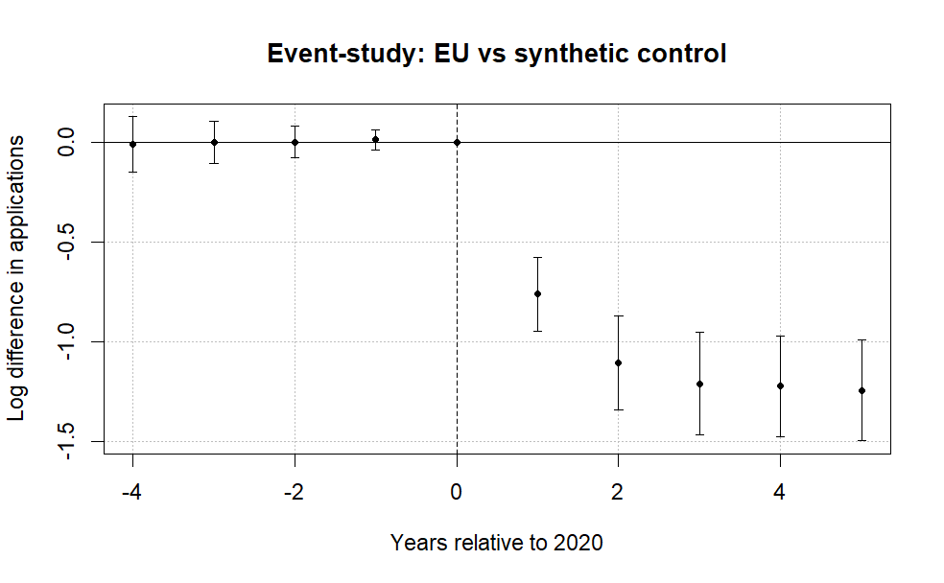
Note: The figure plots coefficients from a difference-in-differences event-study comparing EU applicants to a synthetic control group of non-EU countries. The horizontal axis shows years relative to 2020, the last pre-treatment year. Points represent estimated differences in log applicant counts and bars denote 95% confidence intervals clustered at the country level. The dashed vertical line marks the final pre-treatment year. Pre-treatment coefficients are small and close to zero, while a sharp decline in EU applicant numbers emerges beginning in 2021 after the tuition reform took effect. A joint Wald test cannot reject the null that the pre-treatment coefficients are jointly zero (p = 0.96), providing no strong evidence of differential pre-trends.

Figure 1 reports the event-study coefficients from equation (1). The pre-treatment leads are small and a joint Wald test fails to reject that they are jointly zero (p = .96), providing no evidence of differential pre-trends in this short window. The post-treatment decline persists through 2024 and 2025, which is inconsistent with a purely transitory pandemic explanation.
A leads-only specification likewise finds no evidence of anticipatory adjustment before the reform. The early leads show no systematic pattern and are jointly statistically indistinguishable from zero (p = .96). Allowing country-specific dynamic effects yields similar patterns, with post-treatment coefficients consistently negative across EU countries and pre-treatment estimates near zero (Figure 2). The one exception is Portugal, whose applicant count did not immediately fall in 2021, which traces to a UCAS reporting issue where some Recorded Prior Acceptances were mistakenly submitted as Portugal-domiciled in the 2021 cycle, so the true count is lower than reported (UCAS, 2022).
Figure 2. Saturated DiD event-study estimates by country.
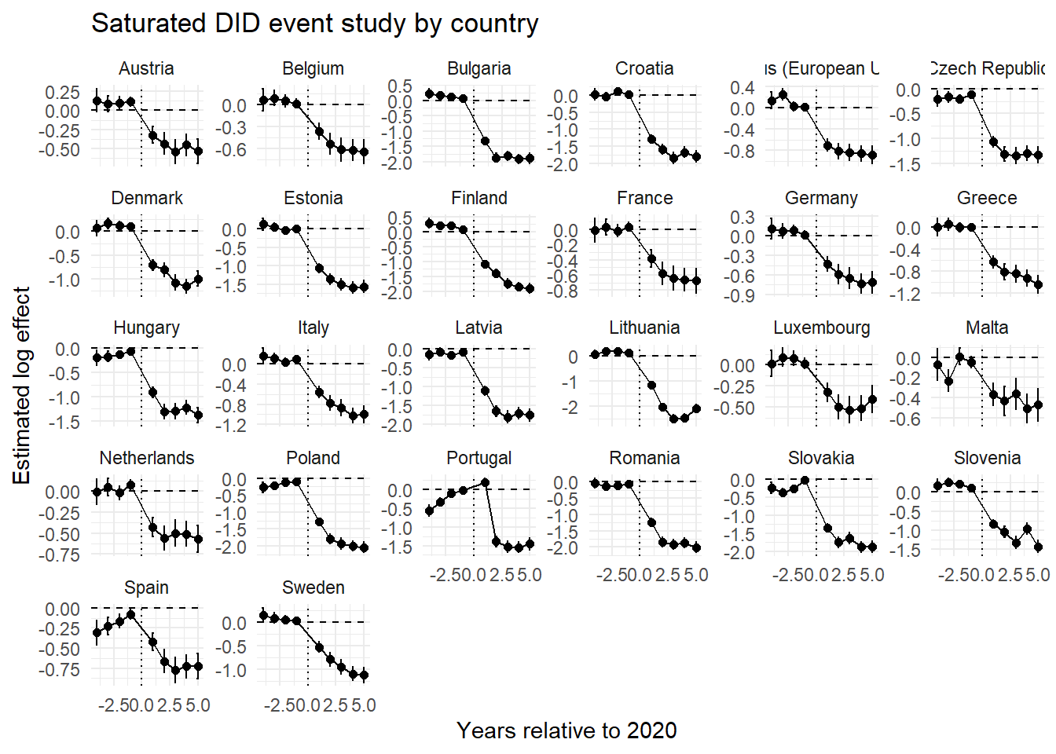Note: Each panel reports country-specific dynamic treatment effects from the saturated difference-in-differences specification comparing EU countries with the pooled control group. Coefficients represent differences in log applicant counts relative to the baseline year (2020).

4.3. Baseline elasticity estimates and heterogeneous price shocks
Let $C$ denote the set of origin countries, partitioned into the treated EU markets $Ω⊂C$ (with Ireland removed), with $J=\left|Ω\right|$, and the candidate donor pool $D=C\backslash Ω$ of non-EU markets. The counterfactual European Union gives a synthetic untreated group, letting us estimate the weighted saturated two-way DiD model:
$$\log{(A_{it})} = α_{i} + γ_{t} +\sum_{\begin{aligned}j∈Ω \\ \end{aligned}}^{ }{β_{j} \left(1\left\{i=j\right\}×Post_{t}\right)} +ρ^{'}X+ ε_{it}$$ | (2)
where $A_{it}$ denotes the applicant count from origin country $i∈C$ in year $t∈[2016, 2025]$, $1\left\{i=j\right\}$ indicates EU member states, and $Post_{t}$ marks the new tuition regime in 2021. Importantly, as long as the two groups remain under different but unchanged tuition fee regimes, their relative applicant-count trajectories should remain stable. When the treated group moves from the UK home-fee regime into the international fee regime already faced by the control group, $β_{j}$ will capture the resulting change in the treated group’s applicant-count trajectory relative to the control group. This relative change identifies the reduction in applicant numbers when the treated group ceased to benefit from UK home-fee status.
To compare the initial and later post-reform periods, we split the post-treatment window into 2021–2023 and 2024–2025. The specification becomes:
$$\begin{matrix}\log{(A_{it})} & = & α_{i} + γ_{t} + \sum_{\begin{aligned}j∈Ω \\ \end{aligned}}^{ }{(β_{j}^{I}\left(1\left\{i=j\right\}×I_{t}\right)}+\sum_{\begin{aligned}j^{ }∈Ω \\ \end{aligned}}^{ }{β_{j}^{L} \left(1\left\{i=j\right\}×L_{t}\right)}+ρ^{'}X+ ε_{it } \\ & & \end{matrix}$$ | (3)
Here $β_{j}^{I}$ is the country-specific log effect for 2021–2023 and $β_{j}^{L}$ is the corresponding effect for 2024–2025. Even though other time-varying shocks may differ across the two windows, the difference
$$Δ_{j}=β_{j}^{L}-β_{j}^{I}$$
can be interpreted as the change in the residual application collapse after the early contemporaneous shocks had subsided, revealing whether the post-reform decline weakened, persisted, or intensified beyond the initial adjustment period (more information in the appendix).
Under a constant-elasticity demand curve, each country-specific log effect maps into a signed price elasticity according to (see the appendix):
$$η_{j}\left(δ\right)=\frac{{\hat{β}}_{j}}{k_{j}\left(δ\right)}$$
Here the numerator is the estimated country-specific log demand effect from earlier specifications and the denominator is the corresponding log price change. We first retain the conventional nominal benchmark, in which the annual price rises from £9,250 to £22,200 and the common log change is 0.875. The loan-adjusted specification then allows the denominator to vary by origin and by the “subjective” discount rate $δ$. Both figures are annual prices, and the initial balance is one year of pre-Brexit tuition, L = £9,250. The interest rate applied to the outstanding balance is
$$i_{jt}=\overline{RPI}+0.03×\left\{\begin{aligned}0, Y_{jt}≤τ_{j}^{L} \\ \frac{Y_{jt}-τ_{j}^{L}}{τ_{j}^{U}-τ_{j}^{L}}, τ_{j}^{L}<Y_{jt}<τ_{j}^{U} \\ 1 , Y_{jt}>τ_{j}^{U}\end{aligned}\right.$$
Under Plan 2, borrowers repay 9% of annual earnings above the country-specific lower overseas threshold. The upper threshold determines the income-related interest loading, which rises linearly from RPI to RPI plus 3 percentage points (UK Government, n.d.-a, n.d.-c; Student Loans Company, 2021). For the baseline $\overline{RPI}$ we use the weighted average of the RPI values from April 2025 (cite: https://www.gov.uk/government/news/student-loans-interest-rates-and-repayment-threshold-announcement--5 ) to march 2026 (cite: https://www.gov.uk/government/news/student-loans-interest-rates-and-repayment-threshold-announcement--6 ) (see appendix). We fix the 2025/26 table’s (cite: https://www.gov.uk/government/publications/overseas-earnings-thresholds-for-plan-2-student-loans/overseas-earnings-thresholds-for-plan-2-student-loans-2024-25 ) lower $(τ_{j}^{L})$ and upper $(τ_{j}^{U})$ thresholds throughout the simulation, hold $\overline{RPI}$ at 3.66%, $Y_{jt}$ is assumed to have nominal wage growth of $g=2\%$ per year, and the loan is written off when T=30-year (UK Government, n.d.-b), the 2024 wage value from Eurostat is extrapolated for 2025 with a growth of 2% ($Y_{it}=w_{j}^{GBP}{\left(1+g\right)}^{t-1}$). With these assumptions, the initial balance and interest recursions are
$$B_{j0}=L, {\tilde{B}}_{jt}=B_{j,t-1}(1+i_{jt})$$
The annual payment equals 9% of earnings above the lower threshold, capped at the balance after interest. The interest recursion begins in the first simulated post-graduation year, even if the borrower earns below the threshold and makes no repayment. The ending balance then becomes the opening balance for the following year.
$$p_{jt}=min\left\{0.09⋅max\left[0,w_{j}^{GBP}{\left(1+g\right)}^{t-1}-τ_{j}^{L}\right],{\tilde{B}}_{jt}\right\}, B_{jt}={\tilde{B}}_{jt}-p_{jt}$$
Discounting the resulting contractual payment stream at the annual subjective discount rate gives:
$$PV_{subjective,j}\left(δ\right)=\sum_{t=1}^{30}{\frac{p_{jt}}{{\left(1+δ\right)}^{t}}}$$
The country-specific experienced price shock is the log difference between the average post-Brexit international fee and the subjective present value of the former loan.
$$k_{j}\left(δ\right)=log\left(22 200\right)-log\left(PV_{subjective,j}\left(δ\right)\right)$$
The post-Brexit price is £22,200 as in Clifton-Sprigg et al. (2025). The pre-Brexit price is the subjective present value of repayments generated by the origin-country wage path. We use the 2024 average annual salary from Eurostat because a student entering in 2021 completes a standard three-year degree in 2024, then convert euro wages into pounds using the 2025/26 rate of 0.85 (posted by the SLC itself). The post-Brexit fee is treated as payable during study once UK government loan access disappears.
The subjective discount rate $δ$ follows the idea in Li et al. (2022) and is therefore a calibration parameter that cannot be independently estimated without micro data. We vary that rate across a sequence of values until the estimated elasticities converge with the literature. Generally speaking, the literature on student subjective discounting is very scarce. Thus far, we don’t have a stable program for estimating the discount rates students experience at the time of application versus the ones they actually face. Guided by the estimates summarized in the literature review (Li et al., 2022; Matousek et al., 2022; Warner & Pleeter, 2001), we evaluate annual rates from 3% to 35%. The 3% case provides a low-discount “objective” rate (the actuary rate), the upper part of the interval captures the strong present orientation found in experimental and consequential financial choices (Matousek et al., 2022). This use of financing access is also consistent with Solís (2017), who shows that credit availability can substantially increase enrollment.
Furthermore, we examine whether the loan adjustment changes the association between the country-specific elasticities and national income. At each subjective discount rate, we estimate
$$\frac{\hat{β_{j}}}{k_{j}(δ)} =α+γ_{δ}\log\left(GDPpc_{j}\right)+X^{'}ρ+ u_{ }$$ | (4)

We report the elasticities at income neutrality, which is defined as the subjective discount rate $δ^{*} ={\arg{\min\left|\hat{γ}\right| }}_{δ∈D}$over the calibration grid $D$. This is the diagnostic point at which the loan-adjusted elasticities no longer vary systematically with national income. It is also informative because it captures the redistributive duality of income-contingent financing. Expected wages relative to the country-specific lower thresholds determine whether and when repayments begin. They compress cross-country income differences through threshold protection. Subsequently, the timing of the resulting payment stream determines how strongly subjective discounting reduces its present value, providing a second form of compression through delayed repayment. An income gradient in $η_{j}(δ)$ may therefore reflect an incomplete adjustment for treatment intensity instead of systematic preference heterogeneity. Income neutrality is not sufficient to identify a uniquely correct discount rate. However, comparing neutral rates across alternative wage-threshold calibrations reveals which side of this duality is dominating the loan income equalizing nature.

5. Results

5.1. Estimated baseline elasticities
Figure 3 reports country-specific elasticities from the difference-in-differences estimates without any time-varying controls. The figure translates the treatment effects into implied demand responses to the Brexit shock. The source regression tables are provided in the appendix.

Figure 3. Decomposition of the post-Brexit demand elasticities by treated country.
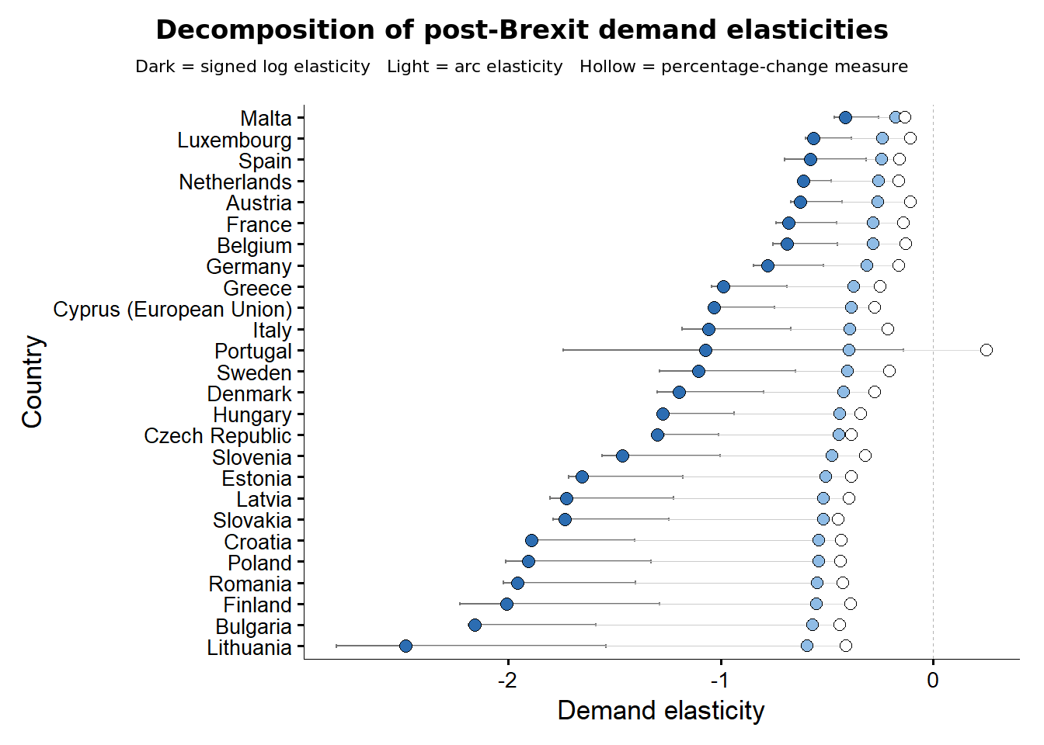
Note: Signed structural log elasticities divide each country-specific effect β_{j} by the common log price change of 0.876. Arc elasticities use [exp(β_{j}) − 1]/1.4, the mechanical percentage-change measure uses the observed change in applications divided by 1.4. R uses natural logarithms. The saturated estimates use Driscoll–Kraay standard errors with one lag. See the online appendix.

The estimates show a large and widespread post-reform contraction. Country-specific effects correspond to applicant reductions ranging from about 30% for Malta to about 89% for Lithuania and 85% for Bulgaria, relative to the control group. The average effect implies a decline of approximately 67%. The implied signed elasticities are negative in every treated country, but their magnitudes vary substantially. Under the common price-shock assumption, lower-income origins such as Bulgaria, Romania, Lithuania, Croatia, and Latvia appear more responsive than Malta, Spain, Luxembourg, the Netherlands, and Austria, with a lot of elasticities sitting in the interval between -2.5 and -1.
The country-specific effects are also positively associated with GDP per capita, meaning wealthier countries experienced smaller declines. Across origins, the Pearson correlation between the estimated effect and log GDP per capita is about 0.51 to 0.56 (0.58 with the Netherlands) in the fixed-effects specification and is statistically significant at conventional levels (Figure 5, Panel A). The gradient is strongest in fixed-effects specifications and remains visible when the saturated model includes the observed macroeconomic controls. The result implies that, to explain the collapse in applicants in some contexts while keeping the assumption that the price shift was equivalent across all contexts, one would have to accept elasticity coefficients above 2.5 for countries like Lithuania and about -2 for Bulgaria. Those numbers stand very far from the conventional estimates in the literature we discussed earlier.
Figure 4 reports country-specific elasticities under homogeneous $k_{j}$ but with a different set of common time varying covariates. The figure shows that the country ordering and the individual magnitudes are stable when the macroeconomic controls are added sequentially. The only visible movement is a small downward shift in the country-specific treatment effect as the controls absorb common variation, althrough this leaves the relative position of each origin essentially unchanged. The persistence of this gradient after the numerator-side adjustments shifts the identification problem to the denominator, raising the possibility that an identical nominal tuition increase generated economically different price shocks once the lost loan is valued across countries.
Figure 4. Saturated DiD specifications with macroeconomic controls added. Namely GDP per capita (PPP, constant prices), population and the percentage of youth unemployment as separate models.
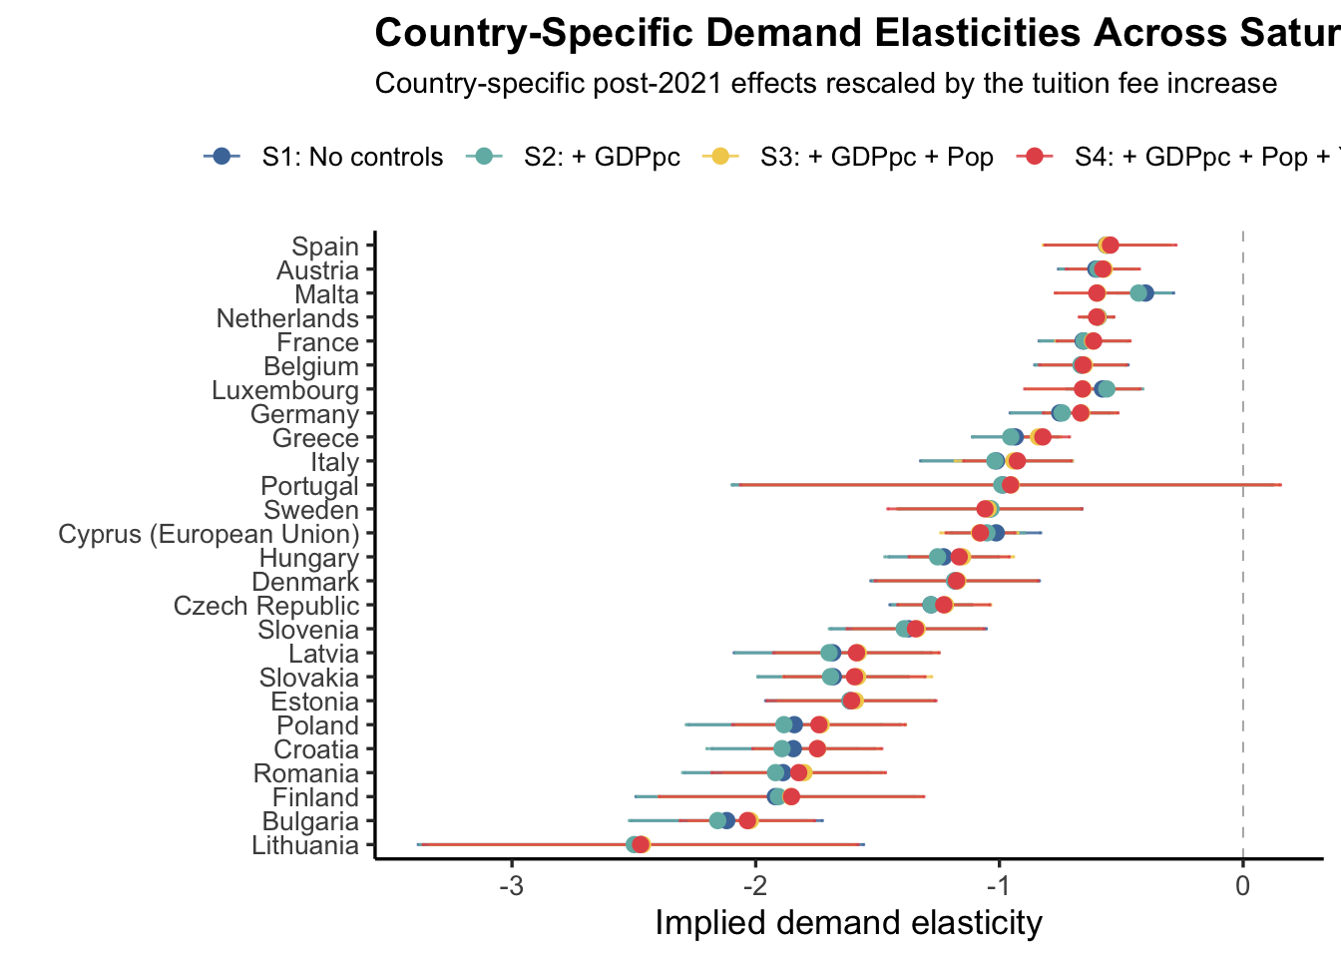
Note: All saturated models use the demeaned version of the free covariates – namely, the GDP per capita, the population and the youth unemployment. Used are Driscoll-Kraay (L=1) standard errors consistently and across all the presented models. Details in the online appendix.

5.2. Loan-corrected elasticities and income neutrality
This section rescales the baseline effects by the price change that each origin country is more likely to have experienced, which lets the apparent income gradient in responsiveness to be reinterpreted. The starting point is the raw pattern in Panel A of Figure 5, where the common price shock elasticities are plotted against the log GDP per capita. The positive slope shows that poorer member states recorded the larger applicant losses, and taken at face value this would suggest that low-income applicants are intrinsically more price sensitive.
Before Brexit, EU applicants could finance UK study through an income-contingent loan whose value reflected the redistributive duality of the system. Country-specific thresholds protected graduates whose expected earnings remained below them, while delayed repayments allowed the remaining obligation to be discounted further into the future. Lower-wage applicants therefore faced later and potentially smaller repayment streams, giving the pre-Brexit loan a lower subjective present value and making the subsequent move to a £22,200 international fee larger than the nominal 140% comparison suggests. Higher-wage applicants crossed their thresholds earlier and repaid sooner, so the former loan retained a higher present value and the effective Brexit price shock was smaller. These countries also experienced smaller applicant declines. Once the larger effects for lower-income origins are divided by their larger effective price changes, and the smaller effects for higher-income origins by their smaller price changes, both the income gradient and the cross-country dispersion contract. Panel B therefore shows the two sides of the loan’s equalizing function operating simultaneously.
Panel B replaces the common nominal price change with the country-specific effective change $k_{j}(δ)$ and plots the resulting loan-adjusted elasticity against GDP per capita at three subjective discount rates. The middle panel marks the discount rate of 14.9 percent, at which the estimated income coefficient$γ_{δ}$ is exactly zero (zero up to the decimal point of precision). Statistical insignificance of the gradient is reached earlier, at 6.3 percent, so the whole plausible range of student discount rates is consistent with no systematic link between national income and price responsiveness.
Figure 5. The cross-country income gradient in demand responsiveness, before and after loan adjustment.
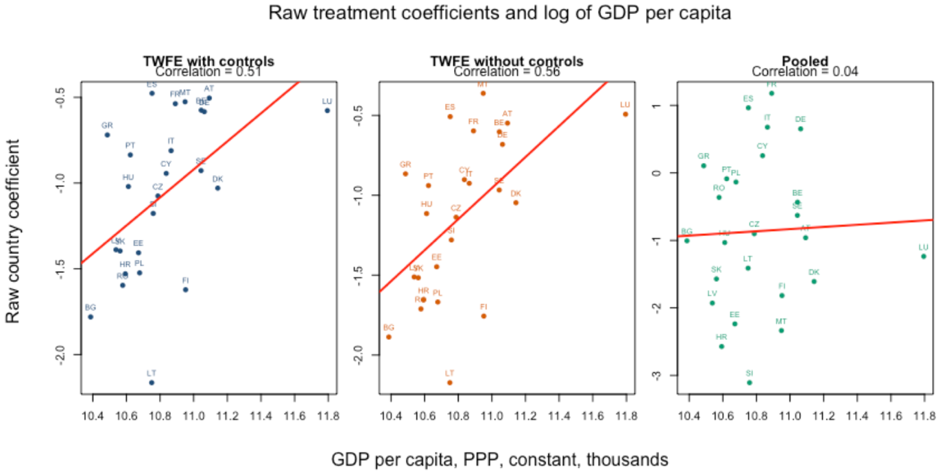
Panel A. Raw treatment effects against GDP per capita

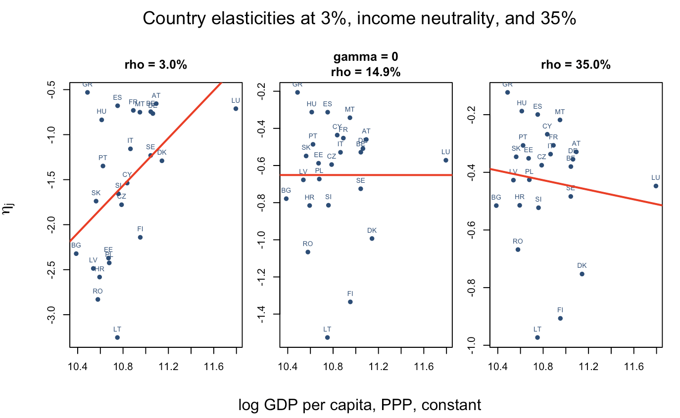
Panel B. Loan-adjusted elasticities against GDP per capita at three discount rates

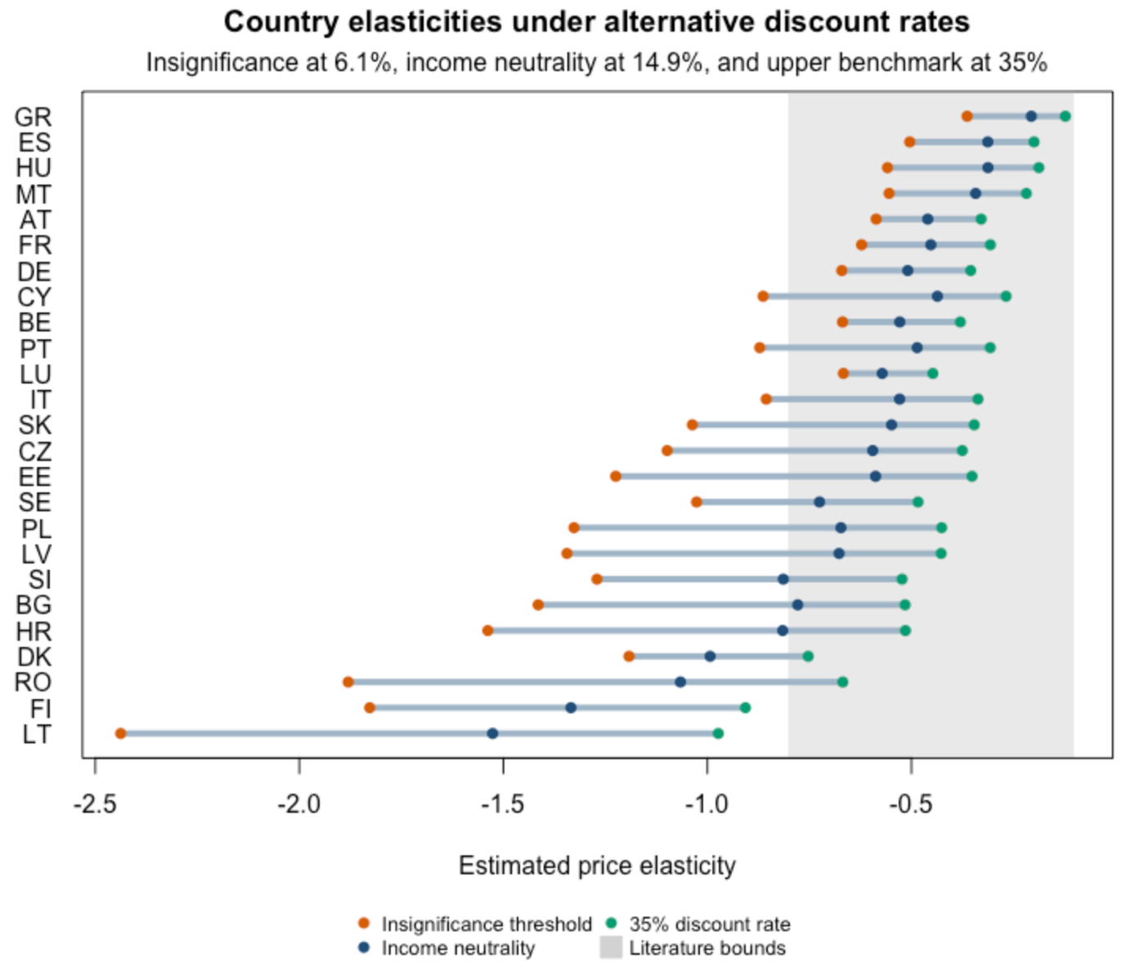
Panel C. Country-specific loan-adjusted elasticities under alternative discount rates
Note: Panel A plots the raw country-specific treatment effect against GDP per capita (PPP, constant fro 2022), when ${\hat{β}}_{j}$ is estimated by pooled and with country and year fixed effects. Panel B plots the loan-adjusted elasticity $\frac{β_{j}}{k_{j}\left(δ\right)}$ against GDP per capita at subjective discount rates of 6.1, 14.9 and 35 percent, where 14.9 percent is the rate at which the income coefficient $γ_{δ}$ equals zero. Panel C reports the country-specific loan-adjusted elasticities under the insignificance threshold (6.1 percent), income neutrality (14.9 percent) and the upper benchmark (35 percent), with the range of prior literature estimates shaded. Details in the online appendix.

Finally, panel C shows the same adjustment at the country level. Under the income-neutral calibration and the higher benchmark rate, the loan-adjusted elasticities for most origins fall inside the range reported in the earlier literature, which is shaded in the panel. Which means that the reconciliation does not depend on implausible elasticities. It only requires that the pre-Brexit loan be valued from the perspective of each origin.
Panel C of Figure 5 also shows that income neutrality is reached only at a relatively high subjective discount rate. One reason is that, under the 2025/26 SLC thresholds and the modeled first-repayment-year wages, 23 of the 25 countries lie above their lower repayment thresholds, leaving little initial threshold protection. This configuration partly reflects rapid nominal wage growth after 2020 relative to adjustments to the administratively determined thresholds. The resulting wage-threshold convergence creates a form of fiscal drag within the loan contract, moving graduates into repayment and weakening its protective function without changing the repayment rate. Section 6.3 examines this mechanism by combining 2021 wages with the 2021/22 SLC thresholds and exchange rate to reconstruct the economic information set prevailing when students applied.

5.3. Descriptive initial and later post-reform effects
Figure 6 compares country-specific log effects in the initial 2021–2023 window with those in 2024–2025. The differences between the dots describe how the estimated post-reform association changed across the two periods.
Figure 6. Initial and later post-reform log effects on the same measurement axis.
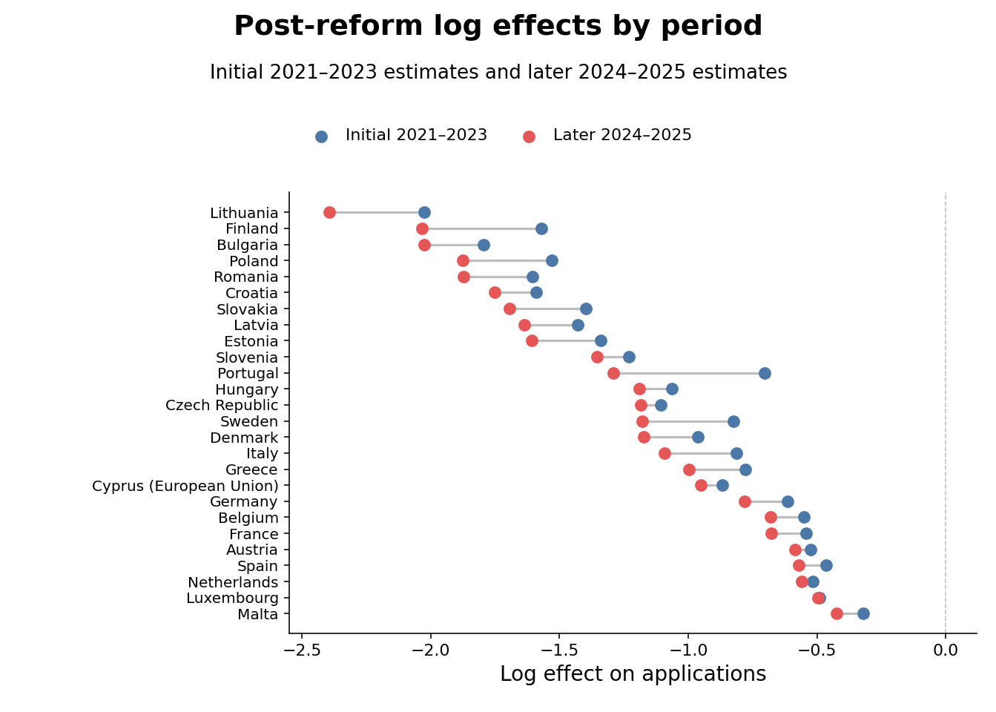
Note: The figure reports country-specific log effects, not elasticities. The initial period is 2021–2023 and the later period is 2024–2025. Both sets of estimates use Driscoll–Kraay standard errors with one lag. The period split is descriptive and does not separately identify a COVID effect.

For nearly all EU-origin countries, the 2024–2025 estimates remain strongly negative and are often more negative than the 2021–2023 estimates, with $Δ_{j}<0$. Such a pattern suggests that the initial reduction was sustained or deepened as successive applicant cohorts adjusted to the higher price, updated their expectations about studying in the United Kingdom, and redirected applications toward alternative destinations. This persistence is inconsistent with a fully transitory disruption such as COVID or other contemporaneous changes that occurred immediately after the pandemic's onset in 2020. In fact, if temporarily restricted mobility was the driving reason behind the collapse, then the 2024- 2025 coefficients should’ve been closer to zero than the initial estimates and $Δ_{j}$ positive (or perhaps began to recover as in Sa (2014, 2017, 2019)).
The initial estimates range from −0.321 for Malta to −2.026 for Lithuania; the corresponding 2024–2025 estimates are −0.423 and −2.394. Excluding Portugal, whose 2021 count has a documented reporting issue, the later coefficients are generally larger in absolute value. These patterns support persistence at the country level, again contradicting a COVID-driven or mobility-attraction story, implying that UK higher education grew steadily less popular among EU students until the system reached a stable equilibrium.

5.4. ATT wealth heterogeneity
Table 3. Average treatment effect and macroeconomic interactions with country and year fixed effects and Driscoll–Kraay standard errors (L = 1)
Variable | (I) | (II) | (III) | (IV) | (V)
ATT | -1.109*** | -1.05*** | -0.981*** | -0.961*** | -1.211***
 | (0.098) | (0.110) | (0.101) | (0.092) | (0.120)
c_log(GDPpc) |  | -0.720* | -0.447 | -0.687* | 0.018
 |  | (0.265) | (0.266) | (0.290) | (0.300)
c_log(Pop15_64) |  |  | 3.077*** | 3.213*** | 2.631***
 |  |  | (0.460) | (0.519) | (0.462)
c_YU |  |  |  | -0.014* | -0.008+
 |  |  |  | (0.004) | (0.004)
ATT×c_log(GDPpc) |  |  |  |  | 0.808***
 |  |  |  |  | (0.136)
ATT×c_log(Pop15_64) |  |  |  |  | 0.100***
 |  |  |  |  | (0.013)
ATT×c_YU |  |  |  |  | 0.011
 |  |  |  |  | (0.006)
Obs. | 520 | 468
R2 Adj | 0.957 | 0.958 | 0.964 | 0.964 | 0.970
R2 Within | 0.585 | 0.586 | 0.644 | 0.652 | 0.708
Note: Models I–V use two-way fixed effects. Model I uses 520 observations for 52 countries in 2016–2025. Models II–V use 468 observations in 2016–2024 because the World Bank controls are capped at 2024. GDP per capita is NY.GDP.PCAP.PP.KD, purchasing-power-parity GDP per capita in constant 2021 international dollars. Logged GDP and population are demeaned over the estimation sample before interactions are formed. All models use Driscoll–Kraay standard errors with one lag. Significance codes are + p < .10, * p < .05, ** p < .01, and *** p < .001

Following an extensive pooled DID specification, the uncontrolled ATT is −1.109, equivalent to exp(−1.109) − 1 = −67.0%. To reconcile this number with other estimates in the literature that assume a common elasticity — for example, Conlon et al.’s (2021) long-run elasticity of −0.354 — requires a specific attribution. Applied to the 140% gross fee increase, that elasticity assigns a log quantity change of −0.354 × ln(2.4) = −0.310 to price, or exp(−0.310) − 1 = −26.7%. The remaining −0.799 log points would be attributed to non-price channels. At their more elastic bound of −0.648, the price channel accounts for a larger share, leaving a residual log change of −0.542.
The same arithmetic runs in reverse. Attributing the whole of our ATT to price, the annual fee increase required for an elasticity of −0.354 to generate it is exp(1.11/0.354) =22.9, a rise of 2,194 percent. Against the pre-Brexit home fee of £9,250, that implies an annual charge of approximately £212,200 rather than the roughly £22,200 actually levied once EU applicants moved to international rates. Even the elastic bound in Conlon et al.’s (2021) of −0.648 requires exp(1.109 / 0.648) = 5.5, an increase of 454 percent, or about £51,200 a year. This change will be possible only for countries where subjective discounting is at least 10%, and expected payments are delayed far into the future. To obtain Conlon et al. (2021) number of $η_{j}=-0.354$ we have to solve for a denominator that gives $k=\frac{1.109}{0.354}=3.13$, so $PV_{loan}=\frac{£22,200}{e^{3.13}}=£968$. That is 10.5 percent of the £9,250 principal. Therefore, the estimates are equal only for an applicant whose income-contingent loan was worth about a tenth of its face value in present-value terms.
A possible criticism is that the collapse in applicants was about more than price. Visa requirements, relocation costs, uncertainty surrounding the change in Home-fee status, and other frictions may all have contributed. This would mean that part of the observed shock was manufactured by forces outside the price channel and that, once these forces were removed, the estimated elasticities would collapse back towards the conventional values in the literature. Accepting this criticism, however, would mean accepting that these non-price forces, or another persistent and unobserved exogenous force distinct from COVID-19 and other temporary post-2021 shocks, were responsible for at least 70% of the estimated ATT. The alternative is that perhaps price really was perceived subjectively and that the main reason for the collapse was financial. The present value of expected loan repayments for Bulgaria, for example, was £11,862.82 under a 3% discount rate, implying only an 87% increase in the effective tuition price after 2021. From a historical perspective, the UK experienced a much larger nominal tuition shock in 2012, when the fee cap increased from £3,000 to £9,000. Yet UCAS estimated that young people were only about 5% less likely to apply than expected. Application rates returned to their long-term trend in 2013 and 2014, while entry rates continued to increase (UCAS, 2014; Murphy et al., 2019). Why did a tripling of the fee cap under an income-contingent loan system produce only a mild and temporary reduction in demand, while the post-Brexit loss of the same financing system produced a persistent collapse?. Said more simply: “the larger sticker-price shock had the smaller response when loan financing survived. The smaller effective-price shock had the enormous response when loan financing disappeared.”
Table 3 also relates the post-reform effect to country-level economic characteristics. The ATT remains large and negative as the observed controls are added. In the interacted specification, the GDP-per-capita and working-age-population interactions are positive and precisely estimated, while the youth-unemployment interaction is not statistically distinguishable from zero.

6. Robustness

6.1. Control-group robustness
We assess sensitivity to control-group choice using several alternative donor pools and an Ireland-only comparison. Prior work motivates these checks, but it does not eliminate the need to evaluate them in the present sample (Clifton-Sprigg et al., 2025), it was established that:
- The event-study estimates provide no evidence of differential pre-trends in the available window.
- The leads-only specification provides no evidence of anticipatory adjustment.
- The Croatian accession design in Clifton-Sprigg et al. (2025) provides related quasi-experimental evidence from an earlier policy change.
We compare the baseline with four alternatives: very poor countries (14 controls), very rich countries (12 controls), OECD countries (14 controls), and Ireland alone. The three multi-country groups are detailed in Table 4.
Table 4. Sample compositions for the alternative control groups
 | Poor | Rich | OECD
Control-group composition | Pakistan, Nepal, Bangladesh, Ethiopia, Uganda,  Tanzania, United Republic of, Rwanda, Mozambique, Malawi,  Sierra Leone, Ghana, Nigeria, Kenya, Zimbabwe | United States of America, Canada, Australia, Norway, Switzerland, Singapore, Qatar, United Arab Emirates, Kuwait, Saudi Arabia, Israel, Japan | Australia, Canada, Chile, Colombia, Iceland, Israel, Japan,  Korea, Republic of, Mexico, New Zealand, Norway, Switzerland,  Turkey, United States of America
EU group | 26
Observations | 400 | 380 | 400
Note: Detailed descriptive statistics for these groups are reported in the supplementary materials.

A further concern is that the Graduate Route, introduced in July 2021, may have raised the appeal of UK study independently of tuition by letting international graduates stay up to two years after finishing (Home Office, 2021), therefore treating the control group and biasing the effect downwards. This is mitigated in two ways. First, because the Route reached treated and control countries alike after 2021, any common increase in appeal is absorbed by year fixed effects and cannot identify the DiD coefficient. Second, the Ireland-only specification is also introduced specifically for that purpose, since Irish citizens kept Common Travel Area rights and did not rely on the Route as other international students did, which limits control-group contamination.
Because this design does not build the control group by constrained optimization, we weight the counterfactual as:
$$w_{j}=\frac{\frac{1}{d_{j}+0.001}}{\frac{1}{J}\sum_{k=1}^{J}{\frac{1}{d_{k}+0.001}}}$$
where $d_{j}=\sqrt{\frac{1}{T}{\sum_{t<2021}^{ }{\left(log\left(A_{jt}\right)-\overline{log\left(A_{t}^{EU}\right)}\right)}}^{2}}$. The results are presented in Figures 7 and 8 for the ATT and the country-specific responses, respectively.

Figure 7. Robustness of the Brexit effect across alternative control-group definitions (pooled DiD estimates).
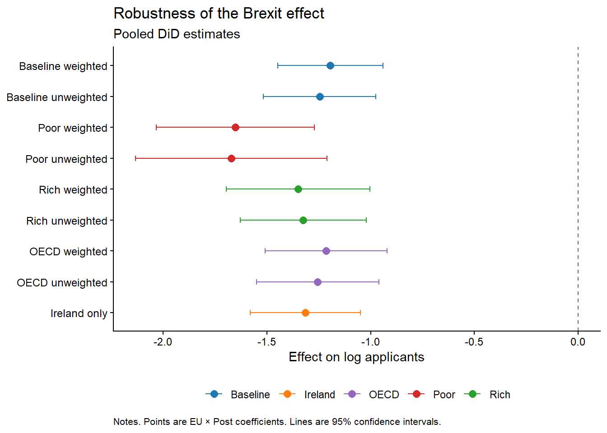
Note: Points are EU × Post coefficients from the pooled difference-in-differences specification; horizontal bars denote 95% confidence intervals. Baseline is the synthetic donor pool used in the main specification; Poor, Rich, and OECD are the alternative control groups described in Table 4, each shown weighted and unweighted; Ireland is a single-country comparison.
Figure 8. Saturated difference-in-differences robustness across control-group specifications.
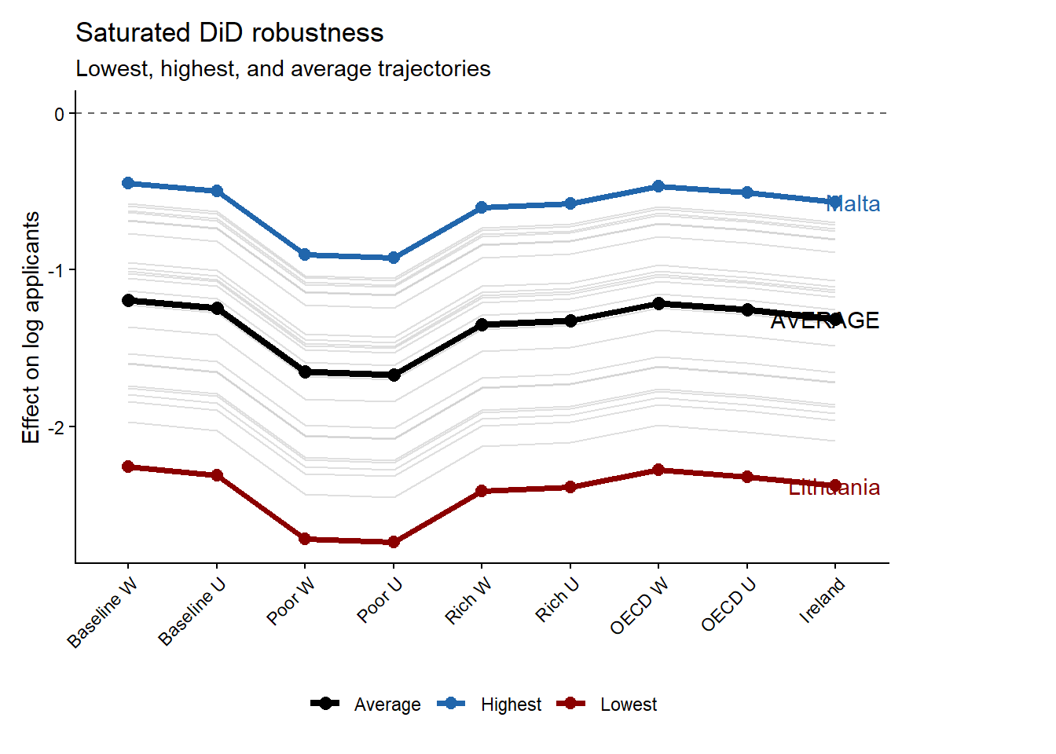
Note: Grey lines show country-specific dynamic treatment trajectories under each alternative control-group specification; the black line marks the cross-specification average. Malta (blue) and Lithuania (red) mark the upper and lower bounds of the estimated effects.

Figures 7 and 8 show that the estimated EU × Post coefficient remains large and negative across the baseline, OECD, high-income, low-income, and Ireland comparisons. Figure 8, demonstrates that the poor-country control group generates the most negative estimates. This is informative because it shows that the decline is not a generic post-pandemic fall in applicant numbers from low-income origins. If that were the mechanism, low-income non-EU countries should absorb much of the EU decline and push the coefficient toward zero.
The Irish case also survives as a robustness check against the Graduate route visa in 2021 both in figure 8 and 7. If the result were driven by common shocks to nearby or culturally connected markets or the Graduate route visa, the comparison with Ireland should substantially weaken the estimate. It does not. The estimate remains close to the other robustness results, reinforcing the interpretation that the post-2021 break reflects the EU-specific loss of Home Fee status and loan access. Figure 8 also strengthens the robustness of the saturared DID results by showing that the ranking of the post-Brexit responses is preserved regardless of the chosen baseline. Another important point is that the weighting of the control group appears to affect the final estimates only at the margin. As a further check that does not rely on the constrained donor weights, we estimate the average treatment effect on the full donor pool with the standalone synthetic difference-in-differences estimator of Arkhangelsky et al. (2021). The estimator returns an ATT of -1.29 (jackknife standard error in 95% CI (-1.464, -1.053)), which falls squarely within the range of the pooled and saturated estimates reported above and confirms that the headline collapse in EU applicant numbers does not hinge on how the counterfactual is weighted.

6.2. Rambachan–Roth parallel-trends checks and synthetic difference-in-differences comparison
In response to a further round of peer review we run two additional robustness checks. The first re-examines the parallel-trends assumption behind the event study in the identification section using the HonestDiD implementation of the sensitivity analysis of Rambachan and Roth (2023), which replaces the binary test of whether pre-trends are flat with a measure of how large a post-treatment violation of parallel trends would have to be before the estimated effect loses its significance. Because the pre-treatment leads are jointly indistinguishable from zero (a joint Wald test gives p = 0.96) and are about two orders of magnitude smaller than the post-treatment coefficients, the loan-driven collapse in EU applicant numbers survives the relative-magnitudes sensitivity analysis across the full range of violations we examine. The robust confidence set for the first post-treatment year never crosses zero, running from −0.94 to −0.58 when no violation is permitted (Mbar equal to zero), from −0.95 to −0.56 when the post-period distortion is allowed to be as large as the worst pre-period deviation (Mbar equal to one), and still only from −0.98 to −0.53 at twice that size (Mbar equal to two). The breakdown value therefore exceeds two, so the result is not an artifact of an assumed pre-trend (Roth, 2022).
The second check re-estimates 26 separate synthetic difference-in-differences regressions, one per treated country, so the Arkhangelsky et al. (2021) estimator collapses to $N_{tr}=1$:
τjsdid=Yj,post-t≤T0 λtjYjt-i∈D​ωijYi, post-t≤T0 λtjYit
Table 5 compares these estimates with the saturated weighted DiD coefficients. After consistently removing aggregates, territories, dependencies, and UK home nations from the donor pool, the two sets correlate at 0.96 and have a mean absolute difference of 0.15 log points, with the synthetic DID estimates larger than the weighted TWFE ones. Portugal and Slovakia have the largest discrepancy at about 0.40 log points but that is expected given Portugal’s documented 2021 reporting issue and Slovakia large baseline effect of about -1.52 log points. The ranking is similar across designs, although several level differences remain economically meaningful. All effects are statistically significant under a placebo based variance covariance matrix (jackknife was not possible due to fact we were using only one treated entity). As expected the correlation with the log of GDP per capita under Synthetic DID is stronger when compared with TWFE, the log-GDP correlation rises from 0.585 under TWFE to 0.661 under synthetic DiD (including the Netherlands)

Table 5. Per-country saturated DiD (TWFE) and synthetic difference-in-differences estimates
Country | Saturated TWFE | Synthetic DiD | Absolute difference
Lithuania | -2,17 | -2,22 | 0,05
Bulgaria | -1,89 | -1,88 | 0,01
Finland | -1,76 | -1,71 | 0,04
Romania | -1,71 | -1,91 | 0,20
Poland | -1,67 | -1,99 | 0,32
Croatia | -1,66 | -1,79 | 0,13
Slovakia | -1,52 | -1,93 | 0,42
Latvia | -1,51 | -1,73 | 0,22
Estonia | -1,45 | -1,52 | 0,08
Slovenia | -1,28 | -1,25 | 0,03
Czech Republic | -1,14 | -1,41 | 0,28
Hungary | -1,11 | -1,39 | 0,28
Denmark | -1,05 | -1,10 | 0,06
Sweden | -0,97 | -1,01 | 0,05
Portugal | -0,94 | -1,43 | 0,49
Italy | -0,93 | -0,97 | 0,05
Cyprus (European Union) | -0,90 | -0,87 | 0,03
Greece | -0,87 | -0,98 | 0,11
Germany | -0,68 | -0,74 | 0,06
Belgium | -0,60 | -0,67 | 0,07
France | -0,60 | -0,73 | 0,13
Austria | -0,55 | -0,62 | 0,07
Netherlands | -0,54 | -0,67 | 0,13
Spain | -0,51 | -0,86 | 0,35
Luxembourg | -0,49 | -0,58 | 0,09
Malta | -0,36 | -0,60 | 0,23
N | 520,00 | 950,00 per regression
Note: Coefficients are on the log-applicant scale. Saturated TWFE effects are the country-specific EU × Post coefficients from the weighted model with 520 country-year observations. Synthetic DiD effects are 26 single-treated-unit estimates against 95 eligible sovereign-country controls (applicants more than or equal to 25). The correlation is 0.96 and the mean absolute difference is 0.15 log points.

6.3. Wage-threshold convergence and repayment protection
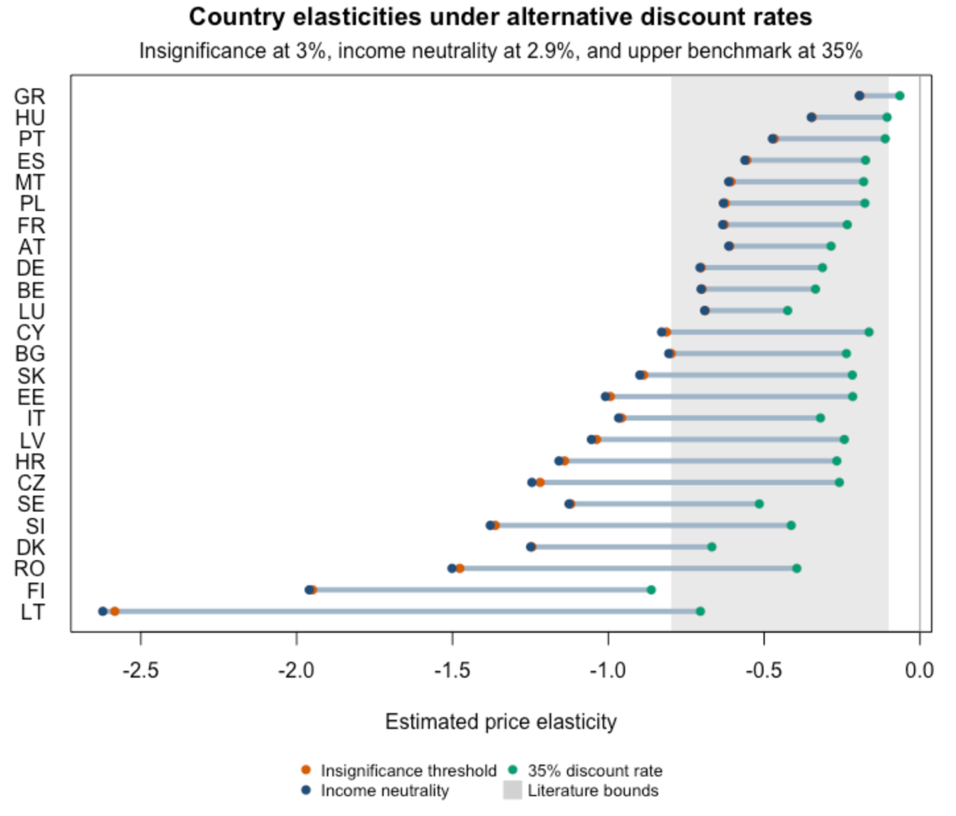
As a timing robustness check, we reconstruct the economic information set prevailing when prospective students applied by combining 2021 wages with the 2021/22 country-specific repayment thresholds and exchange rate. The new weighted average RPI is 1.96% (see appendix). Under this calibration, the estimated relationship between national income and the country elasticities is already statistically insignificant at a subjective discount rate of 3 percent. Exact income neutrality occurs at approximately 2.9 percent.

The reason why the income neutrality occurs much earlier in fig X, can be summarized by the ratio between the country-specific wage and the applicable repayment threshold, $\left(R_{jt}=\frac{w_{jt}}{τ_{jt}^{L}}\right)$. When ($R_{jt}<1$), no immediate repayment is required. When the ratio exceeds one, repayment begins and the present value of the pre-Brexit loan increases. In 2021, 10 of the 25 countries in the wage-calibrated sample had ratios below one. The income-contingent system therefore provided substantial protection to graduates represented by these countries by postponing the beginning of repayment. This lowered the perceived value of the loan and enlarged the effective post-Brexit price increase appearing in the elasticity denominator. Because the largest application declines were generally concentrated among lower-income countries, their larger price denominators moderated the corresponding elasticity estimates. Repayment protection consequently counteracted the original relationship between national income and application responses, producing income neutrality at a comparatively low subjective discount rate. Although similar subjective discount rates are required to pull the country estimates toward the literature range, threshold protection causes the income gradient to disappear much earlier.
The robustness exercise shows that low-rate income neutrality does not, however, imply that the resulting elasticity levels are plausible. At the 2.7 percent neutral rate, only 13 of the 25 country estimates lie within the literature range of −0.80 to −0.10 (fig x). Lithuania illustrates the distinction. Its 2021 wage exceeded its repayment threshold, producing a relatively high loan present value and a small log price shock. Combined with its controlled TWFE coefficient of approximately −2.62, this generates an elasticity of approximately −2.6 (fig x). The aggregate income gradient is therefore neutral because contrasting country patterns cancel one another, even though several individual elasticities remain exceptionally large. This reveals the duality of the income contingent financing. On one side the income differences between applicants are compressed due to lower repayment tresholds relative to the expected earnings (that is why the income gradient collapses immediately on fig x), and the other side income contingent loans compress income differences by allowing subjective discounting to compensate for the lack of immediate financing, achieved by allowing delayed repayments and subsequent discounting of that repayment endlessly into the future.
In 2021, the repayment thresholds performed most of the equalization by protecting graduates in lower-wage countries. Following wage-threshold convergence, this contractual protection weakened and subjective discounting performed more of the equalizing work. The movement from 2.7 to 14.6 percent therefore reflects a change in repayment exposure across countries, while the underlying treatment estimates remain unchanged. More generally, the effective price of an income-contingent loan evolves as nominal wages move relative to administratively determined thresholds, even when the formal loan contract remains unchanged.

7. Discussion

7.1. Why now and not in 2012?
The central puzzle is why EU applicant numbers have not recovered even though the UK remains the second most popular destination for international students globally (Cuibus et al., 2025). The explanation lies in access to the UK higher education market. After 2021, EU applicants lost both home-fee status and access to government-backed tuition loans. Demand could therefore relocate to alternative destinations even if the underlying preference for UK higher education remained intact.
The 2012 and 2021 tuition shocks were not equivalent. The 2012 fee increase was accompanied by continued access to income-contingent tuition loans that covered the regulated fee. The nominal price increased, but students were not required to pay the corresponding amount upfront and could subjectively discount repayments occurring in the future. The 2021 reform simultaneously removed this financing mechanism and exposed new EU applicants to international tuition fees. Brexit therefore changed both the level and the timing of the experienced price. Figure 5 shows that the estimated country coefficients and their relationship with GDP per capita change little across the controlled TWFE, uncontrolled TWFE, and pooled specifications which means that the observed cross-country pattern is not produced by the inclusion of macroeconomic controls in the saturated model.
Figure 9 extends this comparison by tracing the correlations between the implied elasticities and country characteristics across alternative subjective discount rates. At low discount rates, the elasticities are positively correlated with GDP, GNI, and consumption per capita. These correlations weaken as subjective discounting increases, with the GDP and GNI gradients crossing zero near the income-neutral discount rate. Most remaining correlations retain broadly stable signs but are estimated imprecisely.
Intergenerational income persistence follows a particularly interesting pattern. Its correlation with the elasticities is slightly negative at 3%, changes sign near 4%, and then stabilizes at approximately 0.3. Since the estimated elasticities are negative, this positive correlation means that applicants from countries with stronger intergenerational income persistence appear less price sensitive under moderate and high discounting. This is consistent with positive selection. Applicants reaching UK universities from less mobile societies may disproportionately come from affluent families that are better able to absorb the loss of public financing. The HC1 confidence interval nevertheless includes zero at the margin, so the pattern remains suggestive.
The correlation profiles also show that the cross-country ranking of the elasticities is not invariant to the valuation of the loan. The same estimated treatment effects produce different cross-country gradients because the experienced price change depends on starting earnings, repayment thresholds, repayment duration, and subjective discounting. The income-contingent loan compressed these differences and operated as an equalizing institution for European educational mobility. Its withdrawal made household liquidity, access to private finance and (probably) intergenerational income persistance central determinants of entry into the UK market.
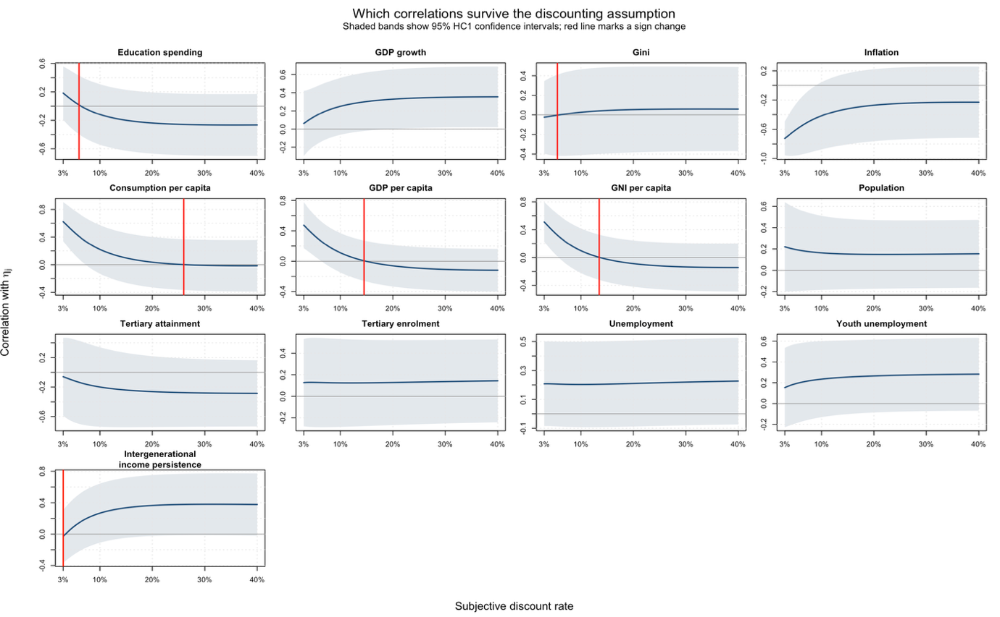
Figure 9. Implied demand elasticity as a function of the economic value of the UK student loan.

Note: all of the covariates were z-score normalized with the scale function in R and pushed through univariate OLS regressions across a sequence of multiple discount rates. Used are HC1 standard errors across all specifications. N is equal to 25. All data is collected from World Bank developmental indicators except the intergenerational wealth indicator that comes from “IGE_Munoz_VanderWeide_June2025.dta” pull and is converted from STATA to R programmatically.

7.2. Are elasticities above one plausible?
The income-neutral panel of Figure 5 shows that the elasticities for Finland, Lithuania and Romania remain larger than one in absolute magnitude even after the income gradient is removed. These estimates are not inconsistent with a well-defined demand curve. Under the constant-elasticity demand function (Q(P)=AP^{\eta}), doubling the price changes demand by the factor (2^{\eta}). An elasticity of −1 therefore implies a 50 percent decline, while an elasticity of −2 implies a 75 percent decline. Values above one in absolute magnitude remain compatible with positive applicant numbers.
Their economic plausibility follows from the institutional character of the pre-Brexit price. EU students did not face the tuition fee as an immediate payment. Access to income-contingent financing transferred part of the cost into the future and conditioned repayment on subsequent earnings. As Section 6.3 shows, wages in 10 of the 25 countries included in the calibration were initially below their applicable repayment thresholds. The loan contract consequently operated as a form of cross-country social insurance, protecting graduates in lower-wage countries through delayed repayment and reducing the perceived value of the pre-Brexit price.
This protection was politically important because it produced an income-neutral application response without requiring equal incomes across Europe. The apparent equality was generated by the repayment system. As nominal wages subsequently increased, eight of the ten initially protected countries crossed above their thresholds. The progressivity of the loan therefore weakened without any formal increase in the repayment rate. This resembles fiscal drag, since nominal wage growth moves graduates into repayment even when their real purchasing power has not converged proportionately. The distributional incidence of an unchanged loan contract can consequently shift without a new political decision.
Brexit removed this protection entirely for new EU students. A country-sensitive and future-contingent obligation was replaced by an immediate international tuition price. Although the post-Brexit fee was formally similar across EU countries, its affordability was not. Removing the loan transferred educational risk from the repayment system to students and their families, exposing differences in national income that the previous financing arrangement had partially absorbed. The large elasticities therefore capture the response to the withdrawal of repayment insurance alongside the increase in the tuition fee.
EU applicants also possessed a wider substitution margin than domestic students. The 2012 reform increased tuition within the UK system while preserving income-contingent financing and leaving domestic applicants principally to choose among institutions facing similar rules. Following Brexit, EU applicants could instead substitute toward comparable programmes in Ireland, the Netherlands or Germany. Elasticities above one consequently describe the reallocation of internationally mobile applicants across national higher education markets. They do not require an equivalent collapse in total European participation. Their magnitude reflects both the high substitutability of the UK as an educational destination and the political decision to replace income-contingent access with an immediate market price.

8. Conclusion
This manuscript establishes three main findings. First, the estimated price elasticities of international student demand are considerably larger than the conventional range between 0.10 and 0.40 reported in much of the literature, with absolute magnitudes exceeding 1.5 for some EU-origin countries. Second, treating Brexit as a common price shock produces a pronounced cross-country income gradient in which applicants from lower-income countries appear substantially more responsive. Third, once the price change incorporates country-specific and subjectively discounted valuations of the lost income-contingent loan, the ordering of the elasticities changes and their absolute magnitudes decline. The income gradient disappears at an annual subjective discount rate of approximately 16%, at which point many of the implied elasticities approach the ranges reported in the literature, although some remain above one in absolute magnitude.
Much of the initial heterogeneity is therefore consistent with differences in the financial intensity of the Brexit shock instead of stable differences in preferences. At income neutrality, the elasticities have weak and imprecisely estimated correlations with the remaining national indicators. Only marginal associations remain with intergenerational income persistence, youth unemployment, and GDP growth. This indicates that the results do not demonstrate a stable macroeconomic profile of price-sensitive applicants. They instead indicate that the income-contingent loan compressed differences in effective treatment intensity and operated as an equalizing institution for European educational mobility.
Finally, the results motivate further research on student mobility, intergenerational income persistence, educational inequality, and the role of subjective discounting in educational choice. Models of international higher education demand should incorporate the portability of student finance, substitution between national systems, and capacity constraints within receiving countries. These mechanisms raise an important distributional question concerning how higher education systems allocate scarce places and public support between domestic and internationally mobile applicants. Future research should establish when international openness expands educational opportunity and when fixed capacity causes access for one group to be rationed against access for another.

References
Abadie, A. (2021). Using synthetic controls: Feasibility, data requirements, and methodological aspects. Journal of Economic Literature, 59(2), 391–425. https://doi.org/10.1257/jel.20191450
Arel-Bundock, V. (2022). WDI: World Development Indicators and other World Bank data (R package version 2.7.8) [Computer software]. https://CRAN.R-project.org/package=WDI
Arel-Bundock, V., Enevoldsen, N., & Yetman, C. J. (2018). countrycode: An R package to convert country names and country codes. Journal of Open Source Software, 3(28), 848. https://doi.org/10.21105/joss.00848
Arkhangelsky, D., Athey, S., Hirshberg, D. A., Imbens, G. W., & Wager, S. (2021). Synthetic difference-in-differences. American Economic Review, 111(12), 4088–4118. https://doi.org/10.1257/aer.20190159
Brown, R. (2011). After Browne: The new competitive regime for English higher education (CSHE Research & Occasional Paper Series No. CSHE.7.11). Center for Studies in Higher Education, University of California, Berkeley. https://escholarship.org/uc/item/9569q5n5
Calhoun, C. (2017). Populism, nationalism and Brexit. In W. Outhwaite (Ed.), Brexit: Sociological responses (pp. 57–76). Anthem Press. https://calhoun.faculty.asu.edu/sites/g/files/litvpz3321/files/publications/articles/populism_brexit.pdf
Campbell, R., & Siegel, B. (1967). The demand for higher education in the United States, 1919–1964. American Economic Review, 57(3), 482–494. https://www.jstor.org/stable/1812115
Clifton-Sprigg, J., Homburg, I., Huyghe, A., & Vujić, S. (2025). International student migration: Did Brexit close the door to EU students? (IZA Discussion Paper No. 18178). IZA Institute of Labor Economics. https://www.iza.org/publications/dp/18178/international-student-migration-did-brexit-close-the-door-to-eu-students
Conlon, G., Lader, R., Halterbeck, M., & Hedges, S. (2021). EU exit: Estimating the impact on UK higher education (Research Report No. DFE-RR1093). Department for Education. https://assets.publishing.service.gov.uk/government/uploads/system/uploads/attachment_data/file/958998/EU_exit_estimating_the_impact_on_UK_higher_education.pdf
Crawford, C., Maris, R., Petit, F., & Wyness, G. (2025). Degrees of demand: Price elasticity in higher education (CEPEO Working Paper Series No. 25-13). UCL Centre for Education Policy and Equalising Opportunities. https://ideas.repec.org/p/ucl/cepeow/25-13.html
Cuibus, M., Walsh, P. W., & Němeček, F. (2025). Student migration to the UK. The Migration Observatory, COMPAS, University of Oxford. https://migrationobservatory.ox.ac.uk/resources/briefings/student-migration-to-the-uk/
Driscoll, J. C., & Kraay, A. C. (1998). Consistent covariance matrix estimation with spatially dependent panel data. Review of Economics and Statistics, 80(4), 549–560. https://doi.org/10.1162/003465398557825
Dwenger, N., Storck, J., & Wrohlich, K. (2012). Do tuition fees affect the mobility of university applicants? Evidence from a natural experiment. Economics of Education Review, 31(1), 155–167. https://doi.org/10.1016/j.econedurev.2011.10.004
Eurostat. (2025). Average full-time adjusted salary per employee [Data set]. https://doi.org/10.2908/NAMA_10_FTE
Findlay, A., King, R., Stam, A., & Ruiz-Gelices, E. (2006). Ever reluctant Europeans: The changing geographies of UK students studying and working abroad. European Urban and Regional Studies, 13(4), 291–318. https://doi.org/10.1177/0969776406065429
Home Office. (2021, July 1). Graduate route for best and brightest launches. GOV.UK. https://www.gov.uk/government/news/graduate-route-for-best-and-brightest-launches
Hoxby, C. M. (1997). How the changing market structure of U.S. higher education explains college tuition (NBER Working Paper No. 6323). National Bureau of Economic Research. https://doi.org/10.3386/w6323
Leslie, L. L., & Brinkman, P. T. (1987). Student price response in higher education: The student demand studies. Journal of Higher Education, 58(2), 181–204. https://doi.org/10.1080/00221546.1987.11778239
Li, H., Campbell, D., & Erdem, S. (2022). Measuring time preferences using stated credit repayment choices. Journal of Quantitative Economics, 20, 43–67. https://doi.org/10.1007/s40953-021-00283-7
Locke, W., & Marini, G. (2021). The rapid increase in faculty from the European Union in UK higher education institutions and the possible impact of Brexit. In F. Huang & A. R. Welch (Eds.), International faculty in Asia (Vol. 21). Springer. https://doi.org/10.1007/978-981-33-4980-3_12
Luthra, R. R. (2020). Mitigating the hostile environment: The role of the workplace in EU migrant experience of Brexit. Journal of Ethnic and Migration Studies, 47(1), 190–207. https://doi.org/10.1080/1369183x.2020.1726173
Matousek, J., Havranek, T., & Irsova, Z. (2022). Individual discount rates: A meta-analysis of experimental evidence. Experimental Economics, 25(1), 318–358. https://doi.org/10.1007/s10683-021-09716-9
Mayhew, K. (2022). Brexit and UK higher education. Oxford Review of Economic Policy, 38(1), 179–187. https://doi.org/10.1093/oxrep/grab043
McFadden, D. (1974). Conditional logit analysis of qualitative choice behavior. In P. Zarembka (Ed.), Frontiers in econometrics (pp. 105–142). Academic Press. https://eml.berkeley.edu/reprints/mcfadden/zarembka.pdf
McQuone, R., & Simons, J. (2025). Counting the cost: Modelling the economic impact of a potential levy on international student fees. Public First. https://www.publicfirst.co.uk/couting-the-cost
Neville, R., Rowe, F., & Singleton, A. (2024). Unraveling the Brexit–COVID-19 nexus: Assessing the decline of EU student applications into UK universities. Data & Policy, 6, Article e45. https://doi.org/10.1017/dap.2024.42
Rambachan, A., & Roth, J. (2023). A more credible approach to parallel trends. Review of Economic Studies, 90(5), 2555–2591. https://doi.org/10.1093/restud/rdad018
Roth, J. (2022). Pretest with caution: Event-study estimates after testing for parallel trends. American Economic Review: Insights, 4(3), 305–322. https://doi.org/10.1257/aeri.20210236
Sá, F. (2014). The effect of tuition fees on university applications and attendance: Evidence from the UK. SSRN. https://doi.org/10.2139/ssrn.2481553
Sá, F. (2017). The effect of university fees on applications, attendance and course choice: Evidence from a natural experiment in the UK [Accepted manuscript]. King’s College London. https://kclpure.kcl.ac.uk/ws/files/97277490/The_E_ect_of_University_Fees_SA_Accepted13July2017_GREEN_AAM.pdf
Sá, F. (2019). The effect of university fees on applications, attendance and course choice: Evidence from a natural experiment in the UK. Economica, 86(343), 607–634. https://doi.org/10.1111/ecca.12278
Savoca, E. (1990). Another look at the demand for higher education: Measuring the price sensitivity of the decision to apply to college. Economics of Education Review, 9(2), 123–134. https://doi.org/10.1016/0272-7757(90)90040-C
Solís, A. (2017). Credit access and college enrollment. Journal of Political Economy, 125(2), 562–622. https://doi.org/10.1086/690829
Student Loans Company. (2021). Overseas earnings thresholds for Plan 2 student loans, 2021–22. GOV.UK. https://www.gov.uk/government/publications/overseas-earnings-thresholds-for-plan-2-student-loans
Student Loans Company. (n.d.). Overseas earnings thresholds for Plan 2 student loans, 2020–21. GOV.UK. Retrieved February 11, 2022, archived under https://web.archive.org/web/20220211005047/https://www.gov.uk/government/publications/overseas-earnings-thresholds-for-plan-2-student-loans/overseas-earnings-thresholds-for-plan-2-student-loans-2020-21
UCAS. (2022). UCAS undergraduate sector-level end of cycle data resources 2021 [Data set]. https://www.ucas.com/data-and-analysis/undergraduate-statistics-and-reports/ucas-undergraduate-sector-level-end-of-cycle-data-resources-2021
UCAS. (2025). Undergraduate sector-level end of cycle data resources 2025 [Data set]. https://www.ucas.com/data-and-analysis/undergraduate-statistics-and-reports/ucas-undergraduate-end-of-cycle-data-resources-2025
UCAS. (2024). UCAS Undergraduate end of cycle data resources 2024 [Data set]. https://www.ucas.com/data-and-analysis/undergraduate-statistics-and-reports/ucas-undergraduate-end-of-cycle-data-resources-2024
UK Government. (n.d.-a). Repaying your student loan: What you pay. GOV.UK. https://www.gov.uk/repaying-your-student-loan/what-you-pay
UK Government. (n.d.-b). When your student loan gets written off or cancelled. GOV.UK. https://www.gov.uk/repaying-your-student-loan/when-your-student-loan-gets-written-off
UK Government. (n.d.-c). How interest is calculated (Plan 2). GOV.UK. https://www.gov.uk/guidance/how-interest-is-calculated-plan-2
Warner, J. T., & Pleeter, S. (2001). The personal discount rate: Evidence from military downsizing programs. American Economic Review, 91(1), 33–53. https://doi.org/10.1257/aer.91.1.33
World Bank. (2025). World Development Indicators [Data set]. https://databank.worldbank.org/source/world-development-indicators
Murphy, R., Scott-Clayton, J., & Wyness, G. (2019). The end of free college in England: Implications for enrolments, equity, and quality. Economics of Education Review, 71, 7–22. https://doi.org/10.1016/j.econedurev.2018.11.007
Universities and Colleges Admissions Service. (2014, November 7). UCAS analysis answers five key questions on the impact of the 2012 tuition fees increase in England. https://www.ucas.com/corporate/news-and-key-documents/news/ucas-analysis-answers-five-key-questions-impact-2012-tuition-fees-increase-england
Crawford, C., & Jin, W. (2014). Payback time? Student debt and loan repayments: What will the 2012 reforms mean for graduates? (IFS Report R93). Institute for Fiscal Studies. https://doi.org/10.1920/re.ifs.2014.0093

From $\frac{ΔlnQ}{ΔlnP}=β$ we have that $ΔlnQ=-1.109$, hence $ΔlnP=\frac{1.109}{0.354}=3.13$, therefore $\frac{P_{1}}{P_{0}}=e^{3.13}=22.94$ and subtracting 1 gives 2194%.
The IFS performed a lifecycle simulation of the pre- and post-2012 student-finance systems for young, full-time, English-domiciled students. It estimated average total loan repayments in real net-present-value terms of £15,075 under the old system and £22,843 under the new system, both in discounted 2014 terms (Crawford & Jin, 2014, p. 24). The modeled repayment burden therefore increased by 51.5%, compared with the 166.7% increase in the annual fee cap from £3,375 to £9,000. Combining the former increase with UCAS’s estimate that young application rates were approximately 5% below their expected trajectory yields an implied log elasticity of $\ln{(0.95)/\ln\left(\frac{22843}{15075}\right)=}-0.123$ For comparison, using the change in the nominal fee cap itself gives $\ln{(0.95)/\ln\left(\frac{9000}{3375}\right)}≈-0.05$
The estimation was based only on countries having more than 25 country-year observations across the entire panel. Including countries with country-year observations of less than 25 changes the estimate by about 0.03. Therefore, N1=26, N0=94, effective observations were 1200 in total after filtration. The panel was fully balanced.

